DEVELOP THE WEB APPLICATION USING NODE-RED

|  |  |
| --- | --- |
| TEAM ID | PNT2022TMID31860 |
| PROJECT NAME | Real-Time River Water Quality Monitoring and Control System |
| MARKS | 4 Marks |

1. Double-click the tab with the flow name, and call it Earthquake Details.
2. Click the hamburger menu, and then click Manage palette. Look for node-red- node- open weather map to install these additional nodes in your palette.

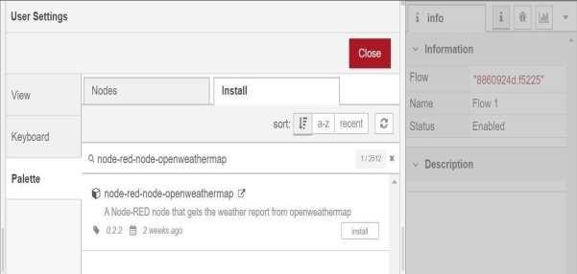

Add an HTTP input node to your flow.

Double-click the node to edit it. Set the method to GET and set the URL to

/earthquakeinfo-hr.

1. Add an **HTTP response** node, and connect it to the previously added **HTTP input** node. All other nodes introduced in this sub-section is to be added between the HTTP input node and the HTTP response node.
2. **Add an HTTP request node and set the URL to**

https://earthquake.usgs.gov/earthquakes/feed/v1.0/summary

/all_hour.geojson, the Method to GET and the Return to a parsed JSON object. This will allow extracting all earthquakes that occurred within the last hour. Name this node Get.

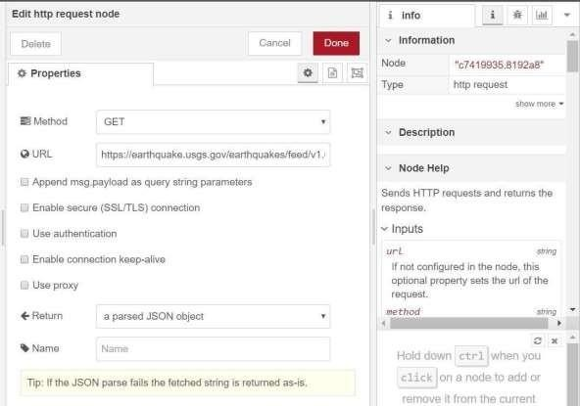

Add a change node. Double-click the node to modify it. Name this node Set Earthquake Info. In the Rules section, add rul to Delete msg.topic, es msg.headers, msg.statusCode, msg.responseUrl and msg.redirectList

"type":properties.type, "magnitude": properties.mag, "location": properties.place,

"longitude":geometry.coordinates[0], "latitude":geometry.coordinates[1], "depth":geometry.coordinates[2], "timestamp": $fromMillis( properties.time